V.L Memorial Public School
475 Vijay Nagar
Chapter - 11 - Questions - Class8th - Maths
CLASS 08 - MATHS (GANITA PRAKASH)
Time Allowed: 6 hours Maximum Marks : 154
 | Section A
1 | Fill in the blanks:  - In the Sierpinski triangle, each triangle at one step produces ________ triangles in the next step.  - If the area of the starting triangle is 1 square unit, then the area remaining after one step of the Sierpinski triangle is ________ square units.  - A pyramid with an n - sided base has ________ edges.  - In the Sierpinski carpet, the relation between holes and remaining squares is$H_{n+1}$ = ________.  - A shape that repeats the same pattern at smaller and smaller scales is called a ________.  - The three standard views used to represent a solid are the front view, the top view and the ________ view. | [6]
 | Section B
2 | Which of the following nets can form a cube?  a) 1 square and 4 triangles  b) 6 equilateral triangles  c) 6 squares  d) 4 rectangles and 2 circles | [1]
3 | The shortest path between two points on the surface of a cuboid is found by  a) always using the same net  b) joining the points by a straight line in space  c) unfolding the cuboid suitably and joining the points by a straight line  d) measuring along its edges | [1]
4 | If the area of the starting triangle is 1 square unit, what is the area remaining at Step 2 in the Sierpinski triangle?  a) $\frac{9}{16}$  b) $\frac{1}{4}$  c) $\frac{1}{16}$  d) $\frac{5}{4}$ | [1]
5 | Which set of views is generally sufficient to describe a solid clearly?  a) Front, top and side views  b) Front and top view  c) Top and side view  d) Only front view | [1]
6 | A single projection of a solid is generally not sufficient to determine the solid uniquely. The main reason is that  a) projections change area  b) different solids can produce the same projection  c) projections are always distorted  d) projections remove parallelism | [1]
7 | In an isometric projection of a cube, the projected lengths of its three mutually perpendicular edges are  a) all different  b) zero  c) two equal and one different  d) all equal | [1]
8 | In a Sierpinski carpet, the fraction of area remaining after each step is  a) $\frac{8}{9}$  b) $\frac{4}{5}$  c) $\frac{3}{4}$  d) $\frac{1}{9}$ | [1]
9 | The perimeter of a Koch snowflake at step 1 is 4 units. What will be the perimeter at step 2?  a) $\frac{12}{3}$ units  b) $\frac{16}{9}$ units  c) $\frac{16}{3}$ units  d) $\frac{9}{4}$ units | [1]
10 | Which of the following best describes a fractal?  a) A shape that shows similar patterns at different scales  b) A figure made only of straight lines  c) A shape having equal area at all steps  d) A shape that repeats exactly only once | [1]
11 | Which statement about the perimeter of the Koch snowflake is correct?  a) It becomes zero in the limit  b) It increases at every step  c) It remains constant  d) It decreases at every step | [1]
12 | If$R_{n}$ denotes the number of remaining squares at step n in a Sierpinski carpet, which formula is correct?  a) $R_{n}=n^{8}$  b) $R_{n}=8^{n}$  c) $R_{n}=9^{n}$  d) $R_{n}=8n$ | [1]
13 | The outline of a solid obtained from a particular direction is called its  a) section  b) vertex  c) net  d) projection | [1]
14 | In a Sierpinski triangle, the fraction of area remaining after one step is  a) $\frac{1}{4}$  b) $\frac{3}{4}$  c) $\frac{2}{3}$  d) $\frac{1}{3}$ | [1]
15 | Which relation correctly represents the number of holes in the Sierpinski carpet?  a) $H_{n+1}=8H_{n}$  b) $H_{n+1}=9R_{n}$  c) $H_{n+1}=H_{n}+R_{n}$  d) $H_{n+1}=R_{n}−H_{n}$ | [1]
16 | A solid has its top view as a circle and front view as a triangle. The solid is a  a) Sphere  b) Cube  c) Cylinder  d) Cone | [1]
17 | Which statement about projections is always true?  a) Parallel edges always project as parallel lines  b) A projection is unique for a solid  c) A square always projects as a square  d) A projection preserves all lengths | [1]
18 | Which of the following features is common to all the three fractals studied (Sierpinski carpet, Sierpinski triangle and Koch snowflake)?  a) They are obtained by repeating the same geometric rule  b) They have finite number of steps  c) They are made only from squares  d) Their perimeters decrease at each step | [1]
19 | In the Sierpinski carpet construction, how many small squares are removed at Step 1?  a) 1  b) 9  c) 8  d) 0 | [1]
20 | Which of the following is a correct net of a cylinder?  a) One rectangle and two circles  b) Two squares and one rectangle  c) Two rectangles and one circle  d) One rectangle and one circle | [1]
21 | A prism has a regular pentagon as its base. How many faces does it have?  a) 10  b) 6  c) 7  d) 5 | [1]
 | Section C
22 | Assertion (A): The remaining area of the Sierpinski triangle becomes smaller at every step.  Reason (R): At each step, one out of four equal triangles is removed from every triangle.  a) Both A and R are true and R is the correct explanation of A.  b) Both A and R are true but R is not the correct explanation of A.  c) A is true but R is false.  d) A is false but R is true. | [1]
23 | Assertion (A): A net containing six squares of different sizes can form a cube.  Reason (R): All faces of a cube must be congruent squares.  a) Both A and R are true and R is the correct explanation of A.  b) Both A and R are true but R is not the correct explanation of A.  c) A is true but R is false.  d) A is false but R is true. | [1]
24 | Assertion (A): In the Sierpinski carpet, the number of remaining squares increases exponentially with the step number.  Reason (R): At every step, each remaining square produces eight new remaining squares.  a) Both A and R are true and R is the correct explanation of A.  b) Both A and R are true but R is not the correct explanation of A.  c) A is true but R is false.  d) A is false but R is true. | [1]
25 | Assertion (A): In an isometric projection of a cube, the projected lengths of all its edges are equal.  Reason (R): In an isometric projection, only one face of the cube is visible.  a) Both A and R are true and R is the correct explanation of A.  b) Both A and R are true but R is not the correct explanation of A.  c) A is true but R is false.  d) A is false but R is true. | [1]
26 | Assertion (A): In the Sierpinski triangle, the number of triangles remaining at step n is $3^{n}$ .  Reason (R): At each step, every triangle is divided into four equal triangles and the central triangle is removed.  a) Both A and R are true and R is the correct explanation of A.  b) Both A and R are true but R is not the correct explanation of A.  c) A is true but R is false.  d) A is false but R is true. | [1]
27 | Assertion (A): In a Sierpinski gasket, the number of equilateral triangles increases at every step.  Reason (R): Each equilateral triangle is divided into smaller triangles during every stage of construction.  a) Both A and R are true and R is the correct explanation of A.  b) Both A and R are true but R is not the correct explanation of A.  c) A is true but R is false.  d) A is false but R is true. | [1]
28 | Assertion (A): A single projection of a solid is enough to uniquely identify the solid.  Reason (R): Different solids can give the same projection on a plane.  a) Both A and R are true and R is the correct explanation of A.  b) Both A and R are true but R is not the correct explanation of A.  c) A is true but R is false.  d) A is false but R is true. | [1]
 | Section D
29 | Write the three standard views used to represent a solid on planes. | [1]
30 | How many vertices does a pyramid with a hexagonal base have? | [1]
31 | Write the formula for the number of remaining squares at step (n) in the Sierpinski carpet. | [1]
32 | How many faces does a prism with an 8 - sided base have? | [1]
33 | If$H_{n}$ denotes the number of holes at step $n$ in the Sierpinski carpet, write the relation between $H_{n+1},H_{n}$ and $R_{n}$ . | [1]
34 | Name the property because of which a fractal looks similar at different scales. | [1]
35 | Write the formula for the number of sides at step n of the Koch snowflake. | [1]
36 | What happens to the length of a line in its projection?  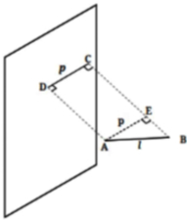 | [2]
37 | A rectangular sheet of paper measuring 12 cm × 8 cm is rolled to form a cylinder along its length. What is the radius of the circular base of the cylinder? | [2]
38 | If a square pyramid has a base with 4 sides, find the total number of faces, edges, and vertices. | [2]
39 | In a Sierpinski triangle, find the number of triangles remaining and the fraction of area remaining after 4 steps. | [2]
40 | A prism has a 12 - sided base. Find the number of faces, edges and vertices of the prism. | [2]
41 | In a Sierpinski carpet, find  - the number of remaining squares and  - the number of holes formed  at Step 3. | [2]
42 | In the Koch Snowflake, if we start with an equilateral triangle with side length 1 unit, how many sides does the shape have at Step 1? | [2]
43 | An ant is at the center of the bottom face of a cube with a side of 4 cm. It crawls along the cube’s surfaces to reach the center of the top face. Find the shortest distance it travels. | [2]
44 | In the Sierpinski Carpet, if we start with a square of area 81 sq. units, what is the total area remaining at Step 1? | [2]
45 | An equilateral triangle of side length 6 cm is used to form a Koch snowflake. The perimeter of the snowflake at step$n$ is $\frac{128}{3} cm$ . Find the value of $n$ . | [2]
46 | Determine the number of sides of the Koch snowflake at the seventh step. | [2]
47 | A regular tetrahedron has all faces as equilateral triangles. If each edge of the tetrahedron is 6 cm:  - How many faces, edges, and vertices does it have?  - How many possible nets does a regular tetrahedron have? | [3]
48 | Can the profile of the same solid look different from different viewpoints? Explain. | [3]
49 | Explain with an example why projections of different objects on a plane can be identical. Draw two different 3D objects that produce the same projection. | [3]
50 | A cuboid has dimensions 8 cm × 6 cm × 4 cm. An ant is at the center of one face (8 cm × 6 cm) and a laddu is at the center of the opposite face. Find the shortest path the ant must travel along the surface. | [3]
51 | In the Koch Snowflake, starting with an equilateral triangle of side length 1 unit:  - Find the number of sides at Step 2  - Find the perimeter at Step 1 | [3]
52 | If a prism has a base that is a regular polygon with 10 sides, find: (i) The number of faces (ii) The number of edges (iii) The number of vertices | [3]
53 | If a pyramid has a base that is a regular octagon (8 sides), find: (i) The number of faces (ii) The number of edges (iii) The number of vertices | [3]
54 | In the Sierpinski Carpet, find the number of remaining squares (R$​_{n}$ ) and holes (H $​_{n}$ ) at Step 3. | [3]
55 | What is the length of the shortest path between the ant and the laddu?  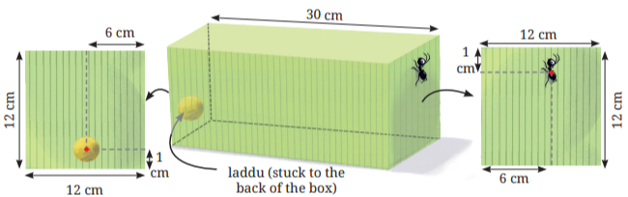 | [3]
56 | In the Sierpinski Triangle, find the number of triangles remaining at Step 3. | [3]
57 | In a Sierpinski Triangle sequence, if the area of the starting triangle at Step 0 is 64 cm², what fraction of the original area remains at Step 3?  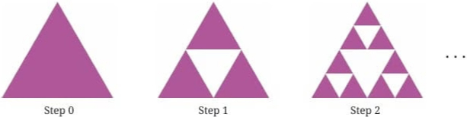 | [5]
58 | What are fractals? Explain with examples of fractals found in nature. | [5]
59 | An ant is at point A (center of a face) and a laddu is at point L (center of the opposite face) on a cuboid with dimensions 6 cm × 8 cm × 10 cm.  - Draw at least two different nets of the cuboid showing possible paths.  - Calculate the length of the shortest path using the Baudhayana (Pythagoras) Theorem.  - Explain why we need to check multiple unfoldings to find the true shortest path.  - If the cuboid dimensions were 4 cm × 4 cm × 10 cm with A and L at centers of opposite 4 × 4 faces, find the shortest path length. | [5]
60 | Kavya observes a solid object from different directions. From the top view, the object appears as a circle of radius 5 cm. From both the front view and the side view, the object appears as a rectangle of height 10 cm. Assuming the solid has a uniform cross - section throughout its height, identify the solid and state its dimensions. | [5]
61 | A rectangular storage box has dimensions 12 cm × 8 cm × 6 cm. An ant is sitting at one corner of the box, and a piece of sugar is placed at the diagonally opposite corner. The ant wants to reach the sugar by crawling along the surface of the box (not flying through the inside). What is the shortest path the ant can take?  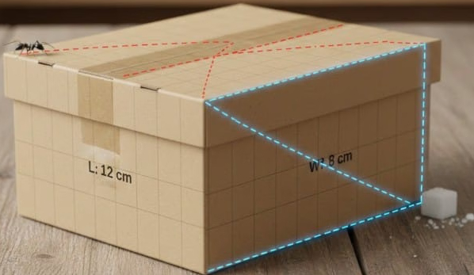 | [5]
62 | In the Sierpinski Triangle, starting with an equilateral triangle of area 64 sq. units:  - What is the area of each small triangle at Step 1?  - What is the total area remaining at Step 1?  - What is the area of the hole at Step 1?  - What is the total area remaining at Step 2? | [5]
63 | In a mathematics exhibition, Priya learned that different 3D shapes can be unfolded into flat patterns called nets. A cube has 11 different possible nets, a tetrahedron has 2 nets, and an octahedron has 11 nets. An octahedron is formed by joining two identical square pyramids at their square bases. Help Priya find out how many faces, edges, and vertices an octahedron has.  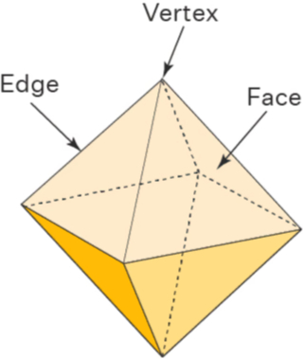 | [5]
64 | A cuboid has dimensions 6 cm × 4 cm × 3 cm.  - Draw a possible net for this cuboid.  - How many vertices does this cuboid have?  - How many edges does this cuboid have?  - An ant is at one vertex and a laddu is at the opposite vertex (diagonally opposite in 3D space). Find the shortest path along the surface. | [5]
65 | Consider the Sierpinski Carpet fractal.  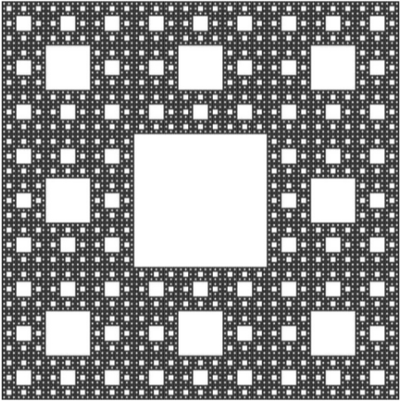  - Draw Steps 0, 1, and 2 of the Sierpinski Carpet.  - Find the number of holes at Step 3 (H$​_{3}$ ).  - If the starting square at Step 0 has an area of 81 sq. units, find the total area removed at Step 2.  - Find a formula for the total area remaining at Step n. | [5]
66 | An ant is at one corner of a cuboid (at point A) and a laddu is at the diagonally opposite corner (at point B). The cuboid has dimensions 3 cm × 4 cm × 12 cm. Find the shortest distance the ant must travel along the surface to reach the laddu. | [5]
 | Section E
67 | Read the following text carefully and answer the questions that follow:  During a forest camping trip, students stayed in a tent house shaped like a triangular prism. The tent has a rectangular base of length 10 m and width 6 m. The triangular front and back faces are isosceles triangles with base 6 m and height 4 m. Students observed the tent from different directions to identify its front view, side view, and top view. They also calculated the surface area to estimate the amount of waterproof fabric used in making the tent.  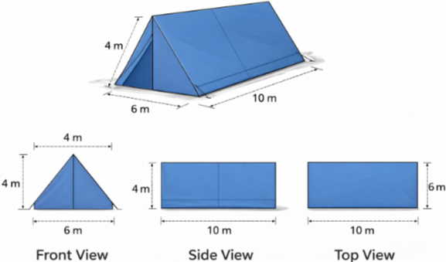  Questions:  - Which solid shape best represents the tent house? (1)  - What is the shape of the front view of the tent? (1)  - Find the area of the triangular front face of the tent. (2)  - OR  - Find the area of the rectangular base of the tent. (2) | [4]
68 | Read the following text carefully and answer the questions that follow:  An engineer is designing a small storage box shaped like a cuboid with dimensions 8 cm × 4 cm × 4 cm. To communicate the design clearly, she draws the front view, top view, and side view of the cuboid. She explains that projections help represent three - dimensional objects on a plane. By analysing the projections, one can understand the shape and dimensions of the solid without seeing the actual model.  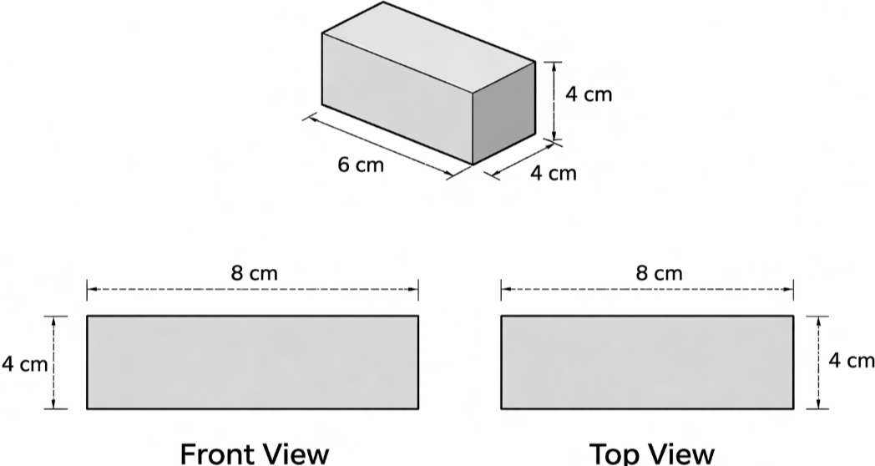  Questions:  - What shape is seen in the front view of the cuboid? (1)  - Which view shows the length and breadth of the cuboid? (1)  - Find the area of the top view of the cuboid. (2)  - OR  - Explain why three projections are generally used to represent a solid. (2) | [4]
69 | Read the following text carefully and answer the questions that follow:  A student is studying a wooden cube of side 6 cm in the geometry lab. To understand its structure, she draws its net and also represents it using front view, top view, and side view. She observes that since all faces of a cube are identical squares, its projections look the same from different perpendicular directions. By analysing its faces, edges, vertices, and projections, she understands how a three - dimensional solid can be represented clearly on a two - dimensional plane.  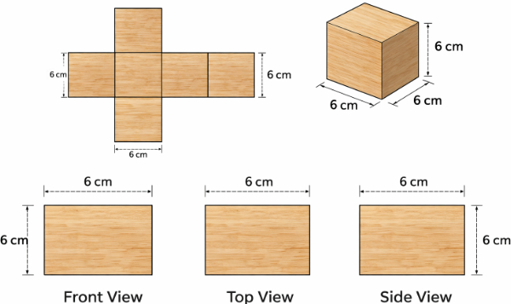  Questions:  - How many faces does a cube have? (1)  - What is the shape of each face of a cube? (1)  - Find the total surface area of the cube. (2)  - OR  - Describe the front view, top view, and side view of the cube. (2) | [4]

